ELET 131 Homework 7

Wednesday, Nov 13, 2013

Name:___________________________________________

Use Word to process your homework and submit a printed hard copy is preferred.

1. (20 points) Determine R_{T} for the networks in Fig. 1.
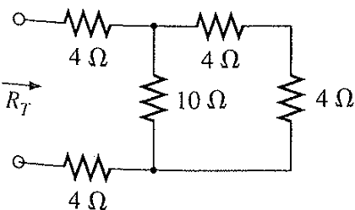
(a)
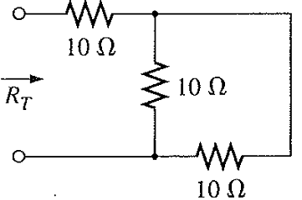
(b)
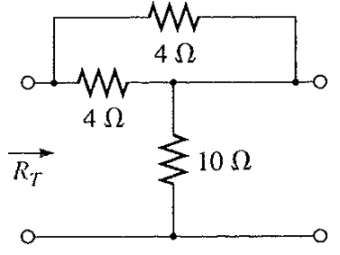
(c)
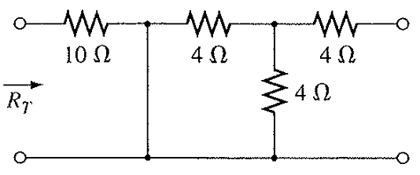
(d)
Figure 1.

2. (20 points) For the network in Fig. 2.
a. Determine R_{T}.
b. Find Is, I₁, and I_{2.}
c. Find voltage V_{a}.

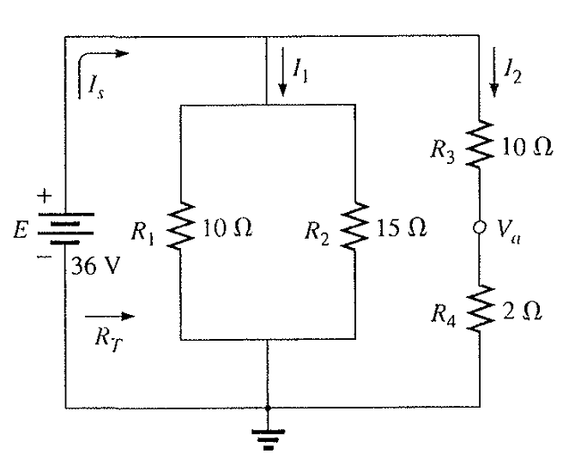
Figure 2.

3. (20 points) For the network in Fig. 3.
a. Determine the current I.
b. Find V₁.

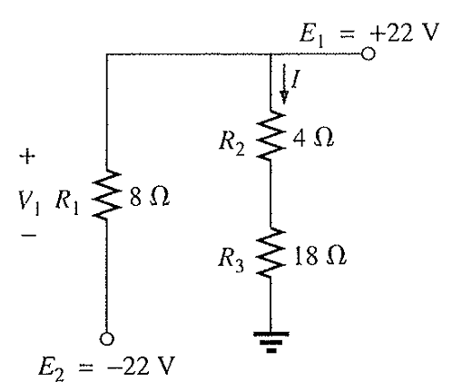
Figure 3.

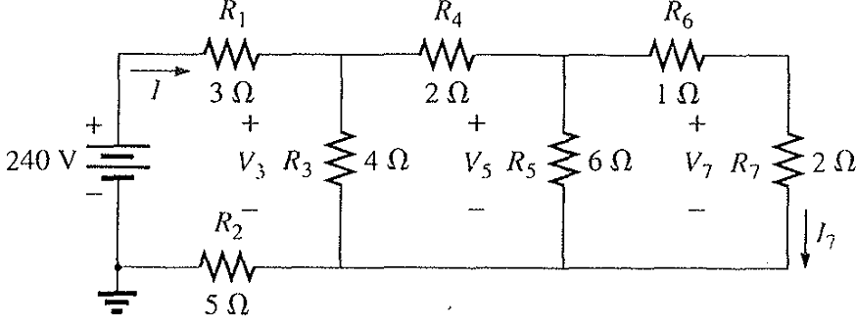
4. (20 points) For the ladder network in Fig. 4:
a. Find the current I.
b. Find the current I₇.
c. Determine the voltage V₃.

Figure 4.

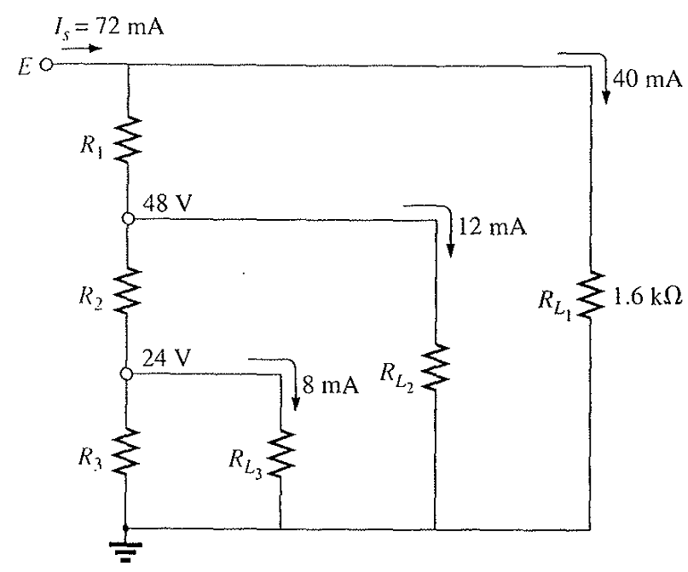

5. (20 points) Given the voltage divider supply Fig. 5:
a. Determine the supply voltage E.
b. Find the load resistors R_{L2} and R_{L3}.
c. Determine the voltage divider resistor R₁, R₂, and R₃.

Figure 5.

